Opening a PDF via Microsoft Edge
When Microsoft Edge defaults to opening via Adobe Acrobat then PDFs can display mis-aligned. To fix the issue, open the PDF directly via Edge.
If you are getting a PDF that displays with misalignments you can fix it by following these steps:

- Click on the Adobe icon in Edge (top right)
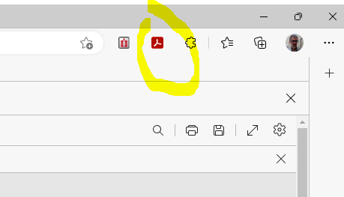

- Click settings icon
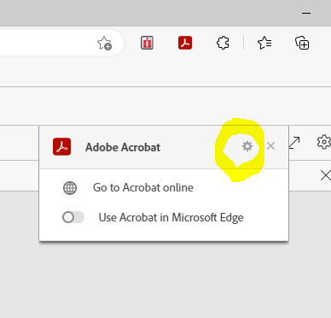

- Switch off ‘open in Acrobat’
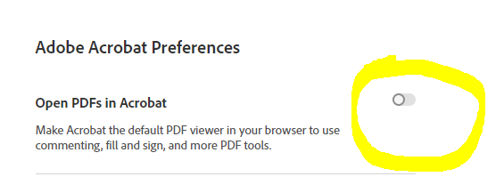

- Click to open PDF and misalignment should no longer be an issue

